Research of the Bugdeting Apps:
- Frollo Frollo.com
- YNAD
- CreditKarma
- Overview of Frollo
Frollo is a free personal finance and budgeting application developed in Australia, Founded in 2015. It is designed to help users manage their finances by providing a complete overview of their income, expenses, savings, and financial goals in one place.
The app uses Open Banking technology, allowing users to securely connect multiple bank accounts without sharing login details. This enables real-time financial tracking and accurate insights into spending behaviour.
Frollo is particularly aimed at individuals who want a simple, automated, and data-driven approach to budgeting without paying subscription fees.
- Key Features
Frollo offers a wide range of features that support effective financial management:
- Account Aggression
Users can link multiple accounts (banking, savings, loans, investments) and view everything in one dashboard.
- Automatic Expense Categorisation
Transactions are automatically grouped into categories such as groceries, salary, and bills.
- Budget Creation and Tracking
Users can create budgets aligned with their income cycle and monitor progress in real time.
- Smart Insights and Alerts
The app provide alerts for unusual spending, upcoming bills, and opportunities to save money.
- Goal Tracking
Users can set financial goals (e.g., saving for a house or emergency fund) and track progress automatically.
- Strengths
Frollo has several strong advantages that make it competitive:
- Completely free with no ads
Unlike many competitors, Frollo does not require subscriptions or display advertisements.
- All-in-one financial dashboard
Provides a complete view of finances across multiple accounts in real time.
- Secure Open Banking integration
Uses regulated data-sharing systems, improving security and trust.
- Automation reduces manual work
Automatic categorisation and tracking make budgeting easier for beginners.
- Proven financial impact
Users reportedly increased savings and reduced debt after using the app.

- Weaknesses
Despite its strengths, Frollo has some limitations:
- Limited customisation for advanced users
Some users report difficulty in customizing categories and budgets fully (especially for detailed tracking).
- Mobile-only experience
Lack of a strong desktop/web version limits deeper financial analysis.
- Occasional technical issues
Reports of data syncing issues or missing transaction history in some cases.
- Learning curve for full features
Although simple at surface level, advanced features may require time to understand
Innovative Features
Frollo stands out due to several modern and innovative elements:
- Open Banking Integration (CDR)
Securely connects financial data without sharing passwords
- AI-Driven Financial Insights
Personalised suggestions based on spending habits
- Real-Time Financial Overview
Live updates of income, expenses, and net worth
- Cashflow Visualization
Displays money in vs. money out in an easy-to-understand format (graph-based)

These are few snapshots of Frollo App:
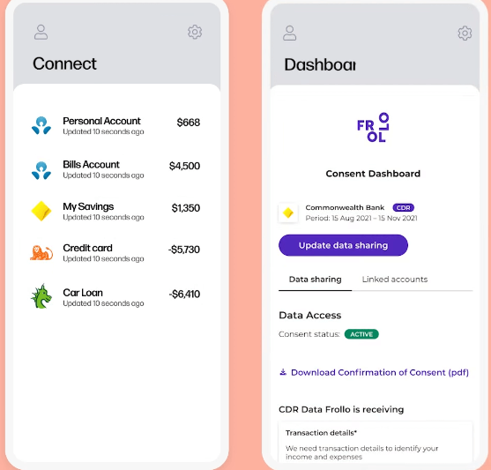

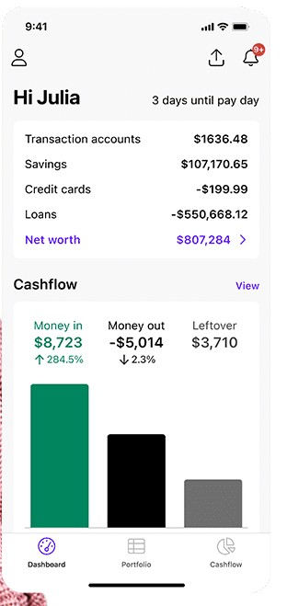

- Overview of YNDA (You Need A Budget)
You Need A Budget (YNAB) is a subscription-based zero-based budgeting system: app that helps users allocate every dollar to specific categories. It is known for its disciplined budgeting philosophy (the “Give Every Dollar a Job” approach) and strong community support. YNAB excels in detailed budget planning.
Key Features:
- Budgeting YNAB’s core feature is zero-based budgeting. Users create budgets for expense categories and must assign each dollar of income, preventing overspending. It also supports: a loan planner tool calculates how extra payments accelerate payoff. Credit Karma, in contrast, has built-in budgeting interface. It does not let users set budget amounts. Instead, it provides a spending overview (tracking transactions and categories) after account linking Method.
- Account Linking: YNAB can aggregate accounts. YNAB uses secure financial APIs (TrueLayer/Plaid for the UK/EU, or its partner in US) to import transactions.
- Transaction Categorisation: YNAB automatically categorizes spending according to its budget categories, aided by a “clever built-in spending categorization feature”. Users can also recategorize manually.
- Bill Tracking: YNAB does not have a dedicated “bill tracker” module; users simply budget for upcoming bills.
- Security & Privacy: YNAB boasts “bank-grade security”: data encryption, two-factor authentication, and audited data centres. It is ad-free and doesn’t sell user data. YNAB Comply with financial data security standards.
Strengths:
- The biggest strength is its disciplined budgeting methodology Many users credit YNAB with reducing financial stress and helping them save – e.g. “We committed to using YNAB and saw… we prioritized our money and improved saving”.
- YNAB’s charts and planners make the budget tangible, and its community support (workshops, forum) is noted. It also excels at multi-device sync: updates happen in real time across web, iOS, and Android, ensuring everyone sees the latest budget.
Weakness:
- The main drawback is cost and learning curve. Many new users find YNAB’s method “tricky” at first (having to pre-assign dollars can feel confusing).
- The subscription fee is a barrier; unlike free apps, users often debate if it’s “worth the money”. Users on Trustpilot also occasionally report syncing glitches (e.g. “bank balances not correct” requiring manual fixes) and frustrating issues with credit card payments not applying correctly.
- It also does not support every banking institution globally
- Some users miss simpler charts or automatic goal features found in other apps. In summary: “super hands-on approach… may be a drawback”.

Innovative features:
- Budgeting Philosophy YNAB’sZero-based system is unique among the group. It enforces proactive planning.
- Savings/gamification: YNAB’s Cost To be Me daily budget concept and social community could be seen as gamified elements.
- YNAB DOES NOT show ads or offers at all.
- YNAB can be used on desktop.
Usability and accessibility:
- YNAB Its UI is clean and focused on budgeting. The main “Budget” screen clearly lists categories and remaining amounts.
- Tutorials (in-app and live workshops) help new users learn the rules. YNAB’s multi-platform support means users can start budgets on desktop and continue mobile; it even works offline and syncs later.
- However, first-time users report a steep learning curve. After onboarding, most find it intuitive. Community reviews praise the app’s flexibility (e.g. customizable budgets, widgets) and “freakishly nice” support team.
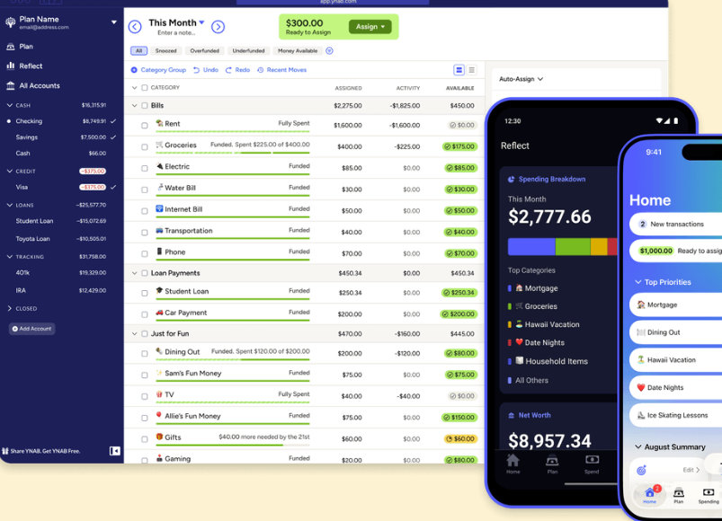
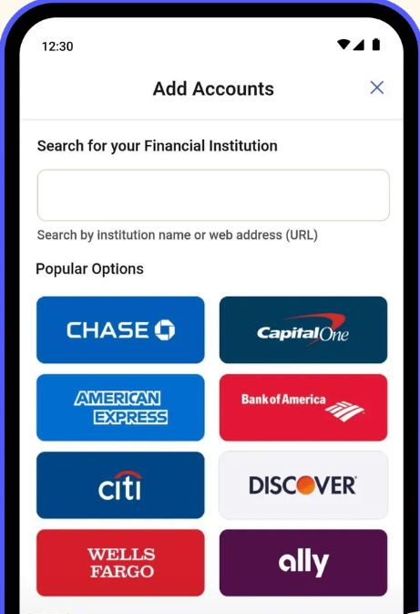

Overview of Credit Karma:
Credit Karma (now owned by Intuit) offers a free personal finance app for US users. It evolved from Mint after Mint’s shutdown. The target users are those who Credi score monitoring. and a basic financial overview without paid fees. The app allows users to Connect bank accounts for spending insights, but it does not provide traditional budgeting tools. It runs on IOS & Android (Apple’s store lists it as “only for iPhone”). The platform is ad-supported (contains ads), and Intuit has explicitly shifted away from offering Mint-style budgets. Instead, Credit Karma focuses on Credits Alerts, personalized offers and transaction monitoring.

  - Key features:
Credit Karma offers a combination of credit monitoring and financial management tools:
- Free Credit Score Monitoring
Users can access their credit scores and reports without paying fees
- Credit Report Insights
Breaks down factors affecting credit score (e.g. payment history, credit usage)
- Spending Tracking
Allows users to view and analyse their transactions
- Credit Alerts
Notifies users of changes to their credit report (e.g. new accounts, inquiries)
- Personalised Financial Recommendations
Suggests credit cards, loans, or financial products based on user profile
- Debt Management Tools
Helps users understand and plan how to reduce debt
- Net Worth Tracking
Provides a broder financial overview including assets & liabilities

  - Strengths
Credit Karma has several strong advantages
- Completely free to use
No subscription fees, making it accessible to a wide audience
- Strong focus on credit education
Helps users understand how credit works and how to improve it
- Real-time alerts and monitoring
Keeps users informed about important financial changes
- User-friendly interface
Simple layout that makes complex financial data easy to understand

- Weaknesses
Despite its strengths, there are some limitations:
- Less focused on budgeting compared to other apps
Budgeting tools are not as advanced as apps like Frollo or YNAB
- Product recommendations can feel promotional
Suggestions for credit cards or loans may be influenced by partnerships
- Limited international availability
Some features are restricted depending on country
- Basic expense tracking
Not as detailed or customizable as dedicated budgeting apps

- Innovative Features:
Credit karma stands out due to its unique approach:
- Free Credit Access Model
Provides credit scores and reports at no cost, which is uncommon
- Credit Score Simulator
Allows users to see how actions (e.g. paying off debt) may impact their score
- Smart Financial Recommendations
Uses user data to suggest relevant financial products
- Integrated Credit + Finance View
Combines credit monitoring with basic budgeting tools in one platform.

Homepage of Credit karma:

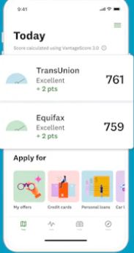

Net worth page:
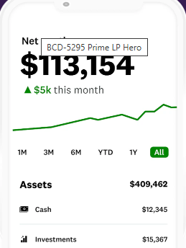
Features I’ll include in my APP:
Feature Category | Frollo | YNAB | Credit Karma | Suggested for My App
Budgeting & Expense Tracking | Automated expense categorization, real-time tracking | Zero-based budgeting, goal-based planning | Basic tracking of expenses | Automated tracking with customizable categories + goal-based budgeting
Financial Insights | AI-driven insights and spending recommendations | Financial reports and analysis | Credit score monitoring & alerts | Insights on spending, budget health, and credit score
Alerts & Notifications | Bill reminders, unusual spending alerts | Budget overspend alerts | Credit alerts, new account alerts | Push notifications for bills, overspending, and credit changes
Savings & Goals | Goal tracking and net worth visualization | Goal allocation for every dollar | Helps manage debt & improve credit | Savings goals, debt management tips, and financial milestones
User Experience | Easy, beginner-friendly interface | Strong financial control & learning curve | Clear dashboards, credit-focused | Clean, simple interface with intuitive navigation

Conclusion

Conclusion
By combining the strengths of Frollo, YNAB, and Credit Karma, your app can offer a complete financial management experience.
- Automation & simplicity from Frollo will make it beginner friendly.
- Structured budgeting and goal setting from YNAB will give users control over their finances.
- Credit monitoring and financial insights from Credit Karma will educate users and improve their financial health.
The result is an app that not only tracks spending but also teaches financial discipline, promotes savings, and provides actionable insights, all in a single, user-friendly platform.

References - Frollo. (n.d.). Frollo App – Budgeting made simple. Retrieved March 24, 2026, from https://frollo.com.au/app/ - Frollo. (n.d.). Frollo – Features overview. Retrieved March 24, 2026, from https://frollo.com.au/frollo-app/ - Google Play Store. (n.d.). Frollo – Money & Budgeting App. Retrieved March 24, 2026, from https://play.google.com/store/apps/details?id=us.frollo.frollo.prod - You Need A Budget (YNAB). (n.d.). YNAB – Budgeting app for control. Retrieved March 24, 2026, from https://www.ynab.com - Google Play Store. (n.d.). YNAB – You Need A Budget App. Retrieved March 24, 2026, from https://play.google.com/store/apps/details?id=com.youneedabudget.evergreen.app - Forbes. (2023). YNAB app review: Is it worth it? Retrieved March 24, 2026, from https://www.forbes.com/advisor/banking/ynab-review/ - Credit Karma. (n.d.). Credit Karma – Free credit score & report. Retrieved March 24, 2026, from https://www.creditkarma.com - Google Play Store. (n.d.). Credit Karma – Credit & Finance App. Retrieved March 24, 2026, from https://play.google.com/store/apps/details?id=com.creditkarma.mobile - PocketGuard. (n.d.). PocketGuard Budgeting App Review. Retrieved March 24, 2026, from https://pocketguard.com/blog/the-full-mint-review-why-it-was-so-popular-and-what-pocketguard-offers-instead/ - NerdWallet. (2023). Mint app review – Is Mint right for you? Retrieved March 24, 2026, from https://www.nerdwallet.com/article/finance/mint-app-review - Reddit. (2023). Frollo app reviews and experiences. Retrieved March 24, 2026, from https://www.reddit.com/r/Frollo/comments/17x6zf1 - Trustpilot. (n.d.). Frollo customer reviews. Retrieved March 24, 2026, from https://www.trustpilot.com/review/frollo.com.au

